**LAPORAN SEMENTARA**

**WORKSHOP TEKNOLOGI WEB DAN APLIKASI**

Izzuddin Ahmad Afif

2421600011

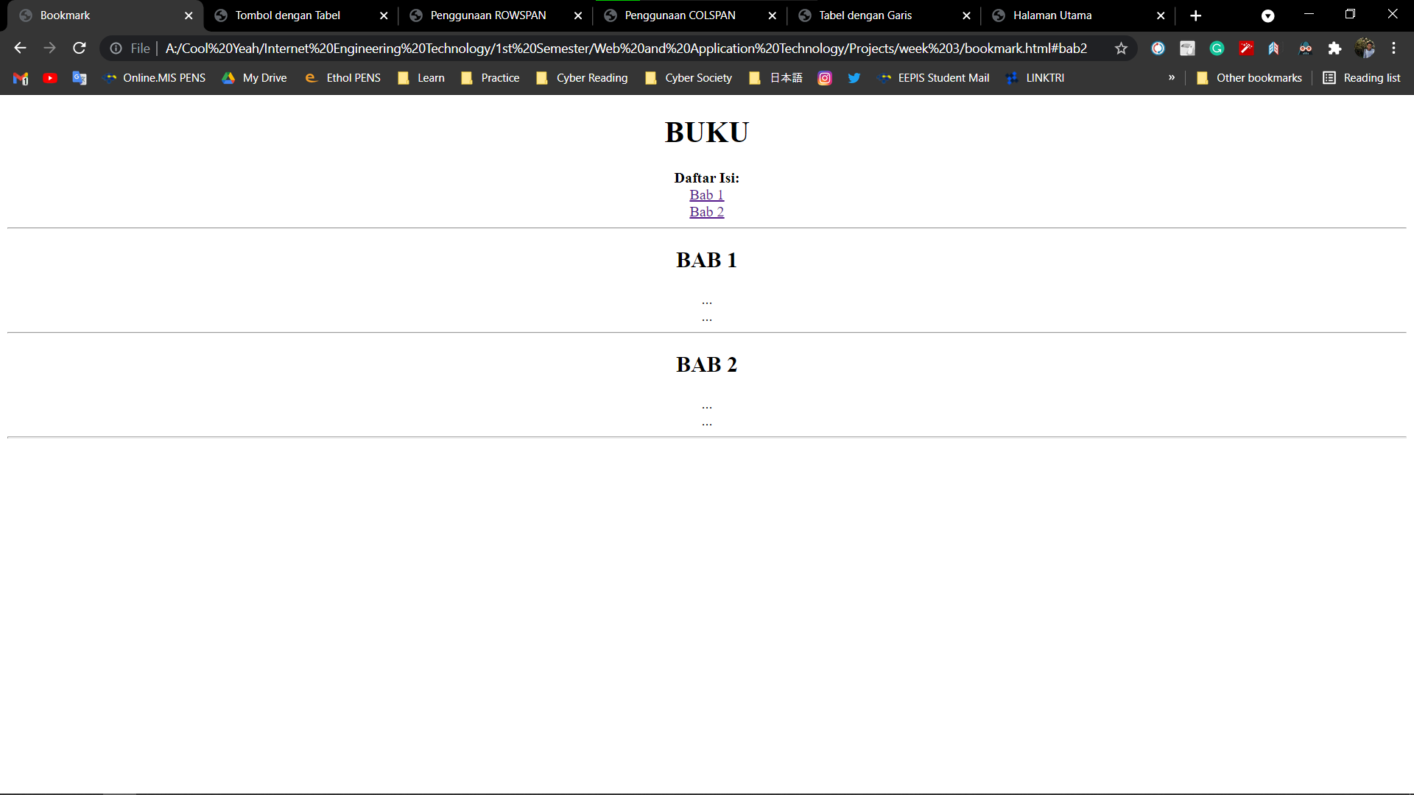

Source code:

<!doctype html>

<head>

<title>Hello World!</title>

</head>

<body bgcolor="black">

<font color="lime" size="4" face="courier">

<h1 align="center">Hello World!</h1>

<hr width="15%" noshad> <!--this is a just a lonely comment, dont mind it LMAO-->

<p style="text-align: justify; text-indent: 0.5in;">

Hello world! My name is Izzuddin Ahmad Afif. I am a freshman majoring in Internet Engineering Technology at Electronics Engineering Polytechnic Institute of Surabaya. I am very passionate about <big><b>Cyber Security</b></big>. For the time being, I am learning about HTML and this is my first project using HTML. There is one thing I like about this Web Programming Language. Apparently, HTML tags are non case-sensitive. So you can use uppercase letter or lowercase at you own will. This suits myself who doesn't really care about writing rules LOL.<br>

<p align="right">I think that's it for now, see you around!<p align="left"><b><big><a href=form.html>Press me!!!</a></big></b></p>

</p>

</p>

<hr noshad>

<h2 align="center">List of My Favorite Subject</h2>

<ul>

<li>Computer Science</li>

<li>Mathematics</li>

<li>Natural Sciences</li>

</ul>

</body>

</html>

Source code:

<!DOCTYPE HTML>

<head>

<title>Form</title>

</head>

<body>

<table border="1" bgcolor="lavender">

<tr align="center"><th colspan ="2">Contact Info</th></tr>

<tr>

<td align="right">Name:</td>

<td><INPUT TYPE = "TEXT" NAME = "nama" SIZE = "20"

MAXLENGTH = "30"></td>

</tr>

<tr>

<td align="right">e-mail:</td>

<td><INPUT TYPE = "TEXT" NAME = "nama" SIZE = "20"

MAXLENGTH = "30"></td>

</tr>

<tr>

<td align="right">Website:</td>

<td><INPUT TYPE = "TEXT" NAME = "nama" SIZE = "20"

MAXLENGTH = "30"></td>

</tr>

<tr>

<td align="right">Comment:</td>

<td><TEXTAREA NAME = "komentar"

ROWS = "5" COLS = "40" WRAP>

</TEXTAREA></td>

</tr>

<tr>

<td></td>

<td align="left"><table border="2" cellspacing="2" cellpadding="2" bgcolor="lime"><tr><td><font color="black"><b>SEND</b></font></font></td></tr></table></td>

</tr>

</body>